
Yeoford Primary School:
Number & Calculation policy: Years 3 & 4

Rationale
It is our intent, based on school research and our study as part of the Jurassic Maths Hub, to provide children with clear methods and strategies in order to build secure foundations in calculation. In Years 3&4 children develop the basis of written methods by building their skills alongside a deep understanding of place value. They should use known addition/subtraction and multiplication/division facts to calculate efficiently and accurately, rather than relying on counting. Children use place value equipment to support their understanding.

Staff will begin units of work with an elicitation task. These tasks will include questions; (2 of each) fluency, reasoning and problem solving being at the heart of these tasks. These tasks will provide staff with a clear picture of children’s knowledge and skills and then allow staff to meet need and extend children’s learning from their individual starting points. They will be used again at the end of a unit of work, enabling staff to see a clear picture of progress and mastery of given areas.

Threaded through all learning across the school we use CAPED to enable children to demonstrate their mastery of mathematics:
C: check it
A: another way
P: prove it
E: explain
D: draw
Age and stage appropriate language and modelling will be found in all classes linked to CAPED

Key Vocabulary:
rounding, partition, place value, tens, hundreds, thousands, column method, whole, part, equal groups, sharing, grouping, bar model

Years 3 & 4
 | Concrete | Pictorial | Abstract
Place value | All children will be taught:
Understanding 100s | Understand the cardinality of 100, and the link with 10 tens.  Use cubes to place into groups of 10 tens.  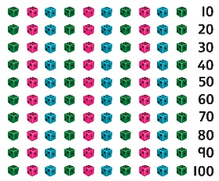 | count in steps of 100.  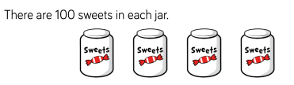 | Represent steps of 100 on a number line and a number track and count up to 1,000 and back to 0.  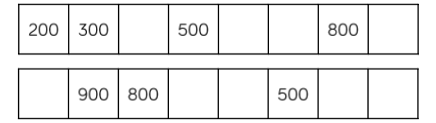
Understanding place value to 1,000 | Unitise 100s, 10s and 1s to build 3-digit numbers.  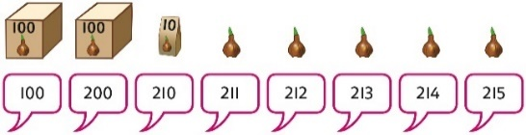 | Use equipment to represent numbers to 1,000.  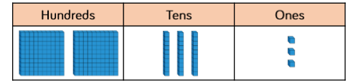 | Represent the parts of numbers to 1,000 using a part-whole model.  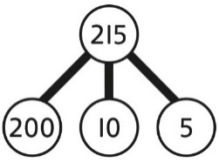  215 = 200 + 10 + 5  Recognise numbers to 1,000 represented on a number line, including those between intervals.
Understanding numbers to 10,000 | Use place value equipment to understand the place value of 4-digit numbers.  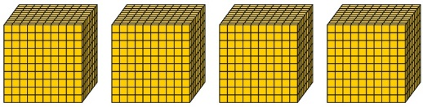  4 thousands equal 4,000. | Represent numbers using place value counters once children understand the relationship between 1,000s and 100s.  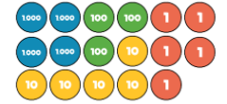  4,000 + 300+ 50 + 5 = 4,355 | Understand partitioning of 4-digit numbers, including numbers with digits of 0.  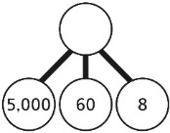  5,000 + 60 + 8 = 5,068  Understand and read 4-digit numbers on a number line.  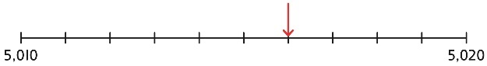
Round to the nearest 10/100/1000 | 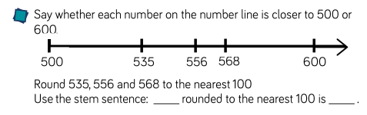 | 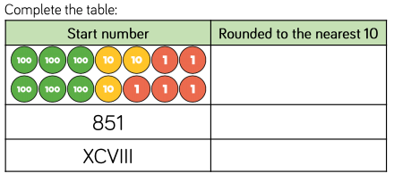 | 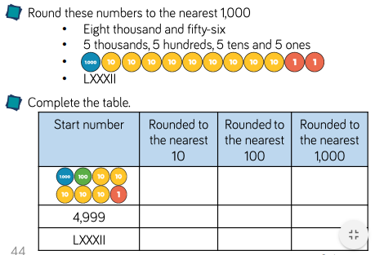
Adding 100s | Use known facts and unitising to add multiples of 100.   +  3 + 2 = 5  3 hundreds + 2 hundreds = 5 hundreds  300 + 200 = 500 | Use known facts and unitising to add multiples of 100.  3 + 4 = 7  3 hundreds + 4 hundreds = 7 hundreds  300 + 400 = 700 | Use known facts and unitising to add multiples of 100.  Represent the addition on a number line.  Use a part-whole model to support unitising.  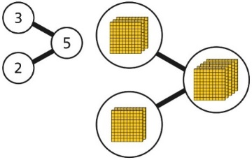  3 + 2 = 5  300 + 200 = 500
Subtracting 100s | Use known facts and unitising to subtract multiples of 100.  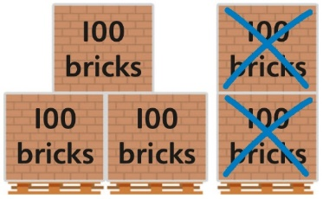  5 − 2 = 3  500 − 200 = 300 | Use known facts and unitising to subtract multiples of 100.  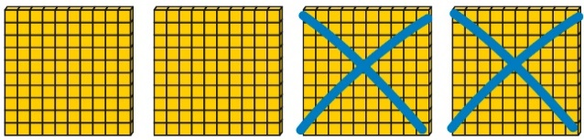  4 − 2 = 2  400 − 200 = 200 | Understand the link with counting back in 100s.  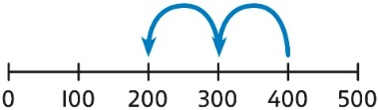  400 − 200 = 200  Use known facts and unitising as efficient and accurate methods.  I know that 7 − 4 = 3. Therefore, I know that 700 − 400 = 300.
Multiplying by multiples of 10 and 100 | Use unitising and place value equipment to understand how to multiply by multiples of 1, 10 and 100.  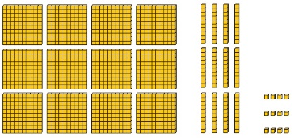  3 groups of 4 ones is 12 ones.  3 groups of 4 tens is 12 tens.  3 groups of 4 hundreds is 12 hundreds. | Use unitising and place value equipment to understand how to multiply by multiples of 1, 10 and 100.  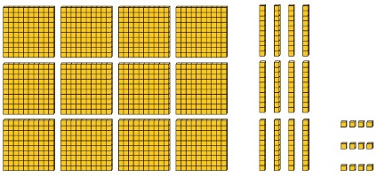  3 × 4 = 12  3 × 40 = 120  3 × 400 = 1,200 | Use known facts and understanding of place value and commutativity to multiply mentally.  4 × 7 = 28  4 × 70 = 280  40 × 7 = 280  4 × 700 = 2,800  400 × 7 = 2,800
Addition | All children will be taught the column method. Place value equipment will be used to represent additions and support mathematics where necessary. Other methods may also offer support to secure knowledge and skills.  All children will be taught to add1/10/100 without exchange and then add 1/10/100 with exchange
 | Concrete | Pictorial | Abstract
3 / 4-digit number + 1s, no exchange or bridging | Use number bonds to add the 1s.  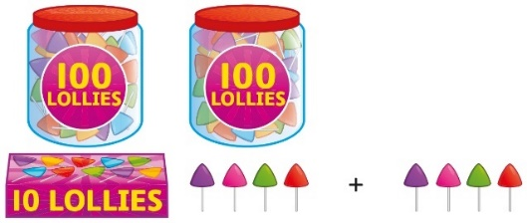  214 + 4 = ?  Now there are 4 + 4 ones in total.  4 + 4 = 8  214 + 4 = 218 | Use number bonds to add the 1s.  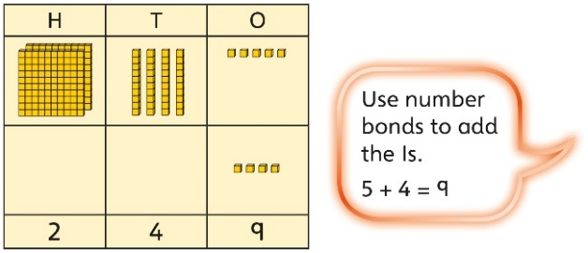  245 + 4  5 + 4 = 9  245 + 4 = 249 | Understand the link with counting on.  245 + 4  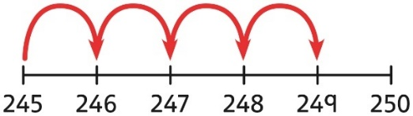  Use number bonds to add the 1s and understand that this is more efficient and less prone to error.  245 + 4 = ?  I will add the 1s.  5 + 4 = 9  So, 245 + 4 = 249
3 / 4-digit number + 1s with exchange | Understand that when the 1s sum to 10 or more, this requires an exchange of 10 ones for 1 ten.  Children should explore this using unitised objects or physical apparatus. | Exchange 10 ones for 1 ten where needed. Use a place value grid to support the understanding.  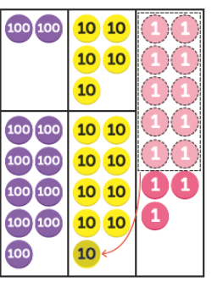 | Understand how to bridge by partitioning to the 1s to make the next 10.  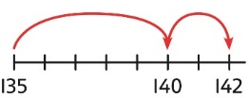  135 + 7 = ?  135 + 5 + 2 = 142 Ensure that children understand how to add 1s bridging a 100.  198 + 5 = ?  198 + 2 + 3 = 203
3-digit number + 10s, no exchange | Calculate mentally by forming the number bond for the 10s.  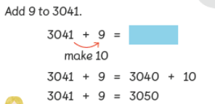 | Calculate mentally by forming the number bond for the 10s.  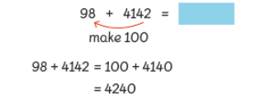 | Calculate mentally by forming the number bond for the 10s.  753 + 40  I know that 5 + 4 = 9  So, 50 + 40 = 90  753 + 40 = 793
3-digit number + 2-digit / 3 digit number, exchange required | Use place value equipment / grids to model addition and understand where exchange is required.  There are 13 ones, so that is 1 ten and 3 ones. There are 14 tens so I will exchange. |  | Use a column method with exchange. Children must understand how the method relates to place value at each stage of the calculation.  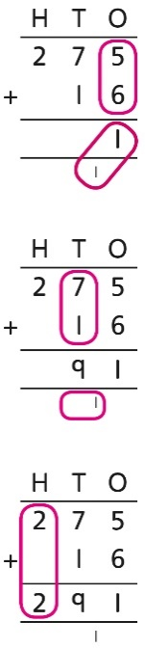  275 + 16 = 291
Representing additions and checking strategies |  | Bar models may be used to represent additions in problem contexts, and to justify mental methods where appropriate.  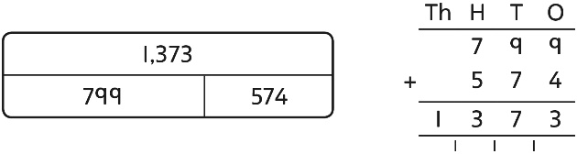  I chose to work out 574 + 800,  then subtract 1. | Use rounding and estimating on a number line to check the reasonableness of an addition.  912 + 6,149 = ?  I used rounding to work out that the  answer should be approximately  1,000 + 6,000 = 7,000.
Subtraction | All children will be taught column subtraction. Place value equipment will be used to represent subtractions and support mathematics where necessary. Other methods may also offer support to secure knowledge and skills.  All children will be taught to subtract without exchange and then subtract with exchange
Subtraction | Concrete | Pictorial | Abstract
3-digit number − 1s, no exchange | Use number bonds to subtract the 1s.  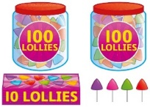  214 − 3 = ?  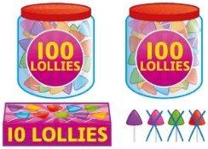  4 − 3 = 1  214 − 3 = 211 | Use number bonds to subtract the 1s.  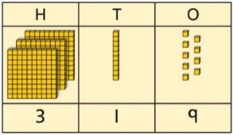  319 − 4 = ?  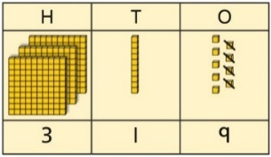  9 − 4 = 5 319 − 4 = 315 | Understand the link with counting back using a number line.  132-4  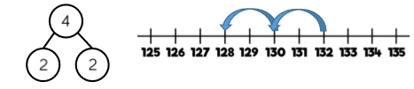
3-digit number − up to 3 / 4-digit number | Use place value equipment to explore the effect of splitting a whole into two parts, and understand the link with taking away.  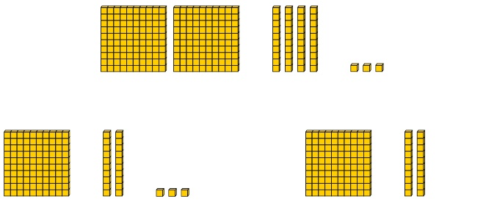 | Represent the calculation on a place value grid.  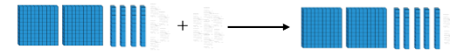  - | Use column subtraction to calculate accurately and efficiently.  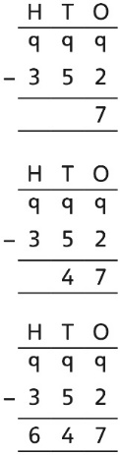
3-digit number − up to 3-digit number, exchange required | Use equipment to exchange 1 hundred for 10 tens, and 1 ten for 10 ones.  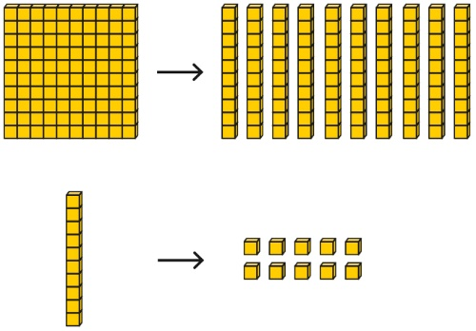 | Model the required exchange on a place value grid.  175 − 38 = ?  I need to subtract 8 ones, so I will exchange a ten for 10 ones. | Use column subtraction to work accurately and efficiently.  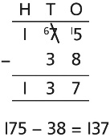
Representing subtraction problems |  | Use bar models to represent subtractions.  ‘Find the difference’ is represented as two bars for comparison.  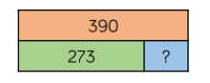  Bar models can also be used to show that a part must be taken away from the whole. | Children use alternative representations to check calculations and choose efficient methods.  Children use inverse operations to check additions and subtractions.  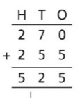  I will check using addition.
Multiplication | All children will be taught times tables to 12x12 and begin with formal written methods for short multiplication
 | Concrete | Pictorial | Abstract
Understanding equal grouping and repeated addition  Using commutativity to support understanding of the times-tables | Children continue to build understanding of equal groups and the relationship with repeated addition.  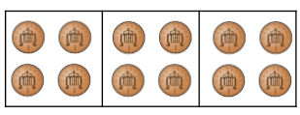  Children recognise that arrays can be used to model commutative multiplications.  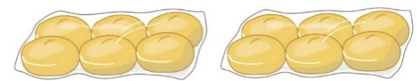  I can see 2 groups of 6.  I can see 6 groups of 2.  2x6=12 6x2=12 | Children recognise that arrays demonstrate commutativity.  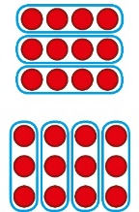  This is 3 groups of 4.  This is 4 groups of 3.  3x4=12  4x3=12 | Children understand the link between repeated addition and multiplication.  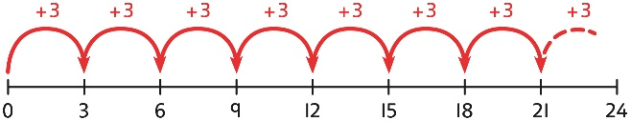  8 groups of 3 is 24.  3 + 3 + 3 + 3 + 3 + 3 + 3 + 3 = 24  8 × 3 = 24  A bar model may represent multiplications as equal groups.  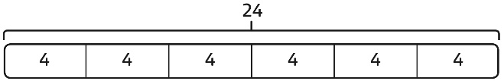  6 × 4 = 24
Learning and understanding times-tables up to 12 × 12 | Learn times tables to 12x12  Understand the special cases of multiplying by 1 and 0.  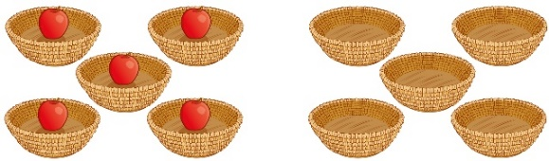  5 × 1 = 5 5 × 0 = 0 | Represent the relationship between the ×9 table and the ×10 table.  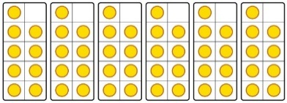  Represent the ×11 table and ×12 tables in relation to the ×10 table.  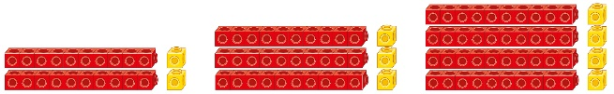  2 × 11 = 20 + 2  3 × 11 = 30 + 3  4 × 11 = 40 + 4  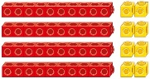  4 × 12 = 40 + 8 | Understand how times-tables relate to counting patterns.  Understand links between the  ×3 table, ×6 table and ×9 table  5 × 6 is double 5 × 3  ×5 table and ×6 table  I know that 7 × 5 = 35  so I know that 7 × 6 = 35 + 7.  ×5 table and ×7 table  3 × 7 = 3 × 5 + 3 × 2  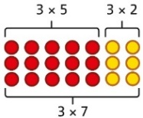  ×9 table and ×10 table  6 × 10 = 60  6 × 9 = 60 − 6
Multiplying a  2-digit number by a 1-digit number, expanded column method | Use place value equipment to model how 10 ones are exchanged for a 10 in some multiplications.  3 × 24 = ?  3 × 20 = 60  3 × 4 = 12  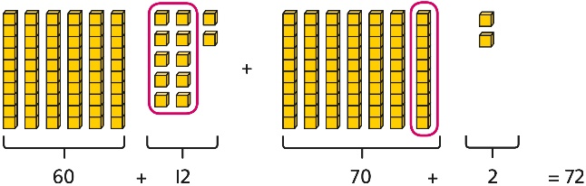  3 × 24 = 60 + 12  3 × 24 = 70 + 2  3 × 24 = 72 | Understand that multiplications may require an exchange of 1s for 10s, and also 10s for 100s.  4 × 23 = ?  4 x 20 = 80  4 x 3 = 12  4 × 23 = 92 | Short multiplication method  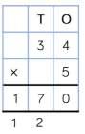
Column multiplication for 2- and  3-digit numbers multiplied by a single digit | Use place value equipment to make multiplications. 26 x 3  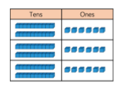  There are 3 × 6 ones… 18 ones  There are 3 × 2 tens … 6 tens  18 + 60 = 78 | Use place value equipment alongside a column method for multiplication of up to  3-digit numbers by a single digit.  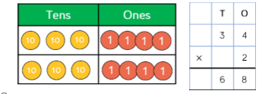 | Use the formal column method for up to  3-digit numbers multiplied by a single digit.  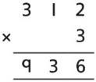
Division | All children will be taught short division method (bus stop)
 | Concrete | Concrete | Concrete
Understanding the relationship between multiplication and division, including times-tables | Use objects to explore families of multiplication and division facts.  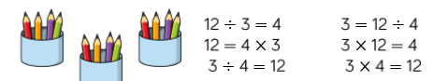 | Represent divisions using an array.    24$÷$4=6 | Understand families of related multiplication and division facts.  I know that 5 × 7 = 35  so I know all these facts:  5 × 7 = 35  7 × 5 = 35  35 = 5 × 7  35 = 7 × 5  35 ÷ 5 = 7  35 ÷ 7 = 5  7 = 35 ÷ 5  5 = 35 ÷ 7
Dividing 2-digit and 3-digit numbers by a single digit by partitioning into 100s, 10s and 1s | Partition into 10s and 1s to divide where appropriate.  39 ÷ 3 = ?    39 = 30 + 9  30 ÷ 3 = 10  9 ÷ 3 = 3  39 ÷ 3 = 13  Use Base 10 equipment to divide where appropriate. |  | Partition into 100s, 10s and 1s using a part-whole model to divide where appropriate.  142 ÷ 2 = ?  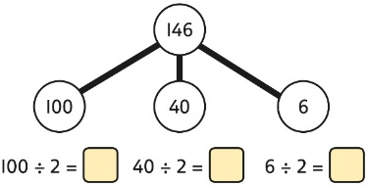  100 ÷ 2 = 50  40 ÷ 2 = 20  6 ÷ 2 = 3  50 + 20 + 3 = 73  142 ÷ 2 = 73
Dividing 2-digit and 3-digit numbers by a single digit, using short division | 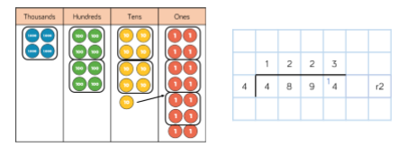 |  | 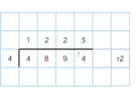
Understanding remainders | Use place value equipment to find remainders.  85 shared into 4 equal groups  There are 24, and 1 that cannot be shared.  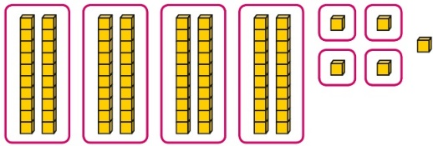 | Represent the remainder as the part that cannot be shared equally.  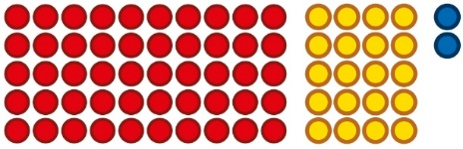  72 ÷ 5 = 14 remainder 2 | Understand how partitioning can reveal remainders of divisions.  80 ÷ 4 = 20  12 ÷ 4 = 3  95 ÷ 4 = 23 remainder 3

